­

CMPG 223

ALL SQL + Screen Prints and User Manual

Group Members

Tshimbiluni Theophillus Nedambale: 33574359

Llayton Titus: 34416579

Siphiwe Mbaya: 33535833

Tshepang Bereng: 32878729

Sekwati Thulare: 28124227

Layton Wylbacht: 32043996

**Databases for Creating:**

Creating Employee Info:

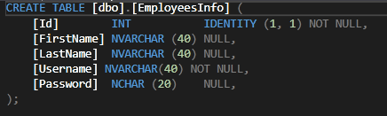

Creating Game:

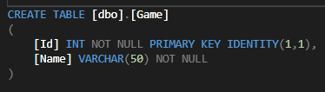

Creating Match Info:

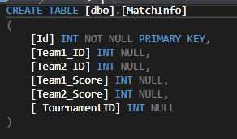

Creating Platform:

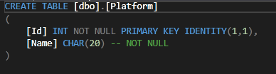

Creating Player:

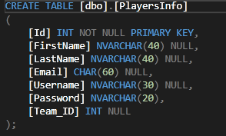

Creating Team:

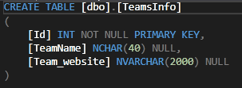

Creating Tournament:

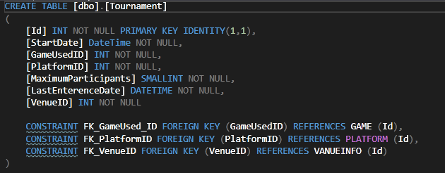

Creating Venue:

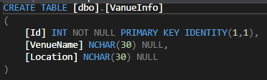

**Maintaining all tables in Database**

Delete Child:



Delete Game:

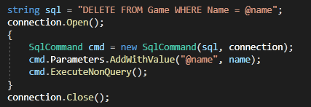

Delete Platform:

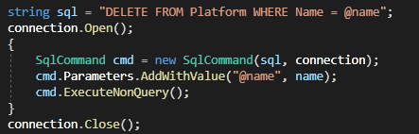

Delete Player:

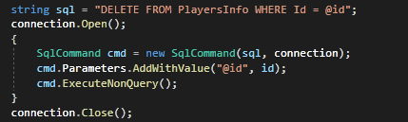

Delete Tournament:

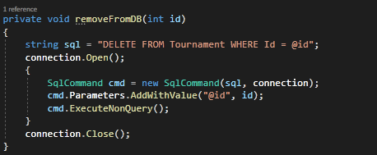

Delete Venue:

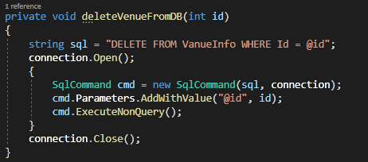

Email Notifications:

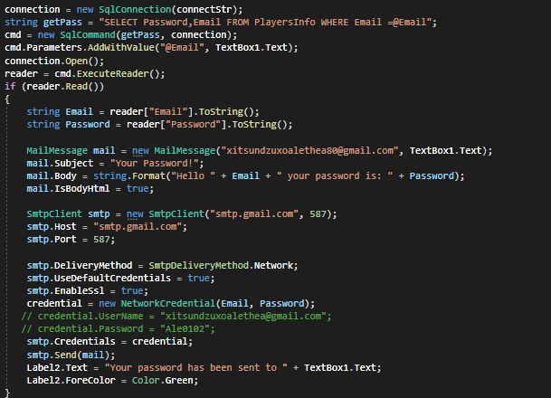

Group by Statement:

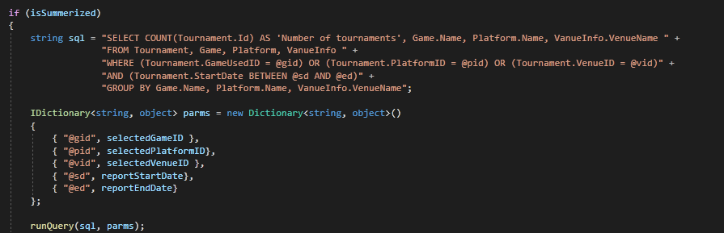

Insert Game:

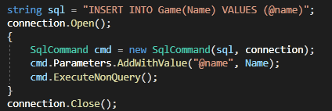

Insert Into Player:

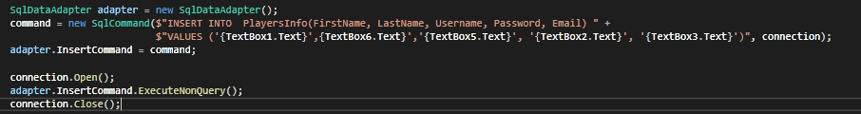

Insert Platform:

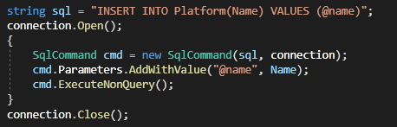

Insert Teams:

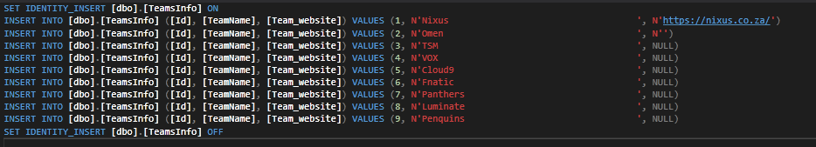

Insert Tournament:

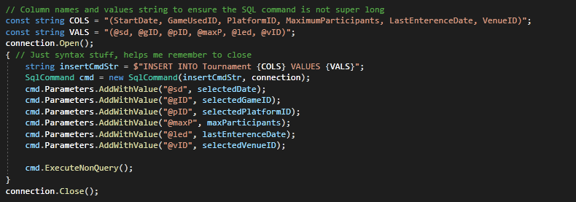

Insert Venue:

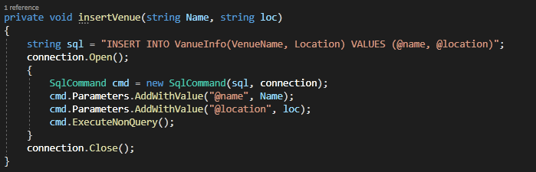

Read Employee:

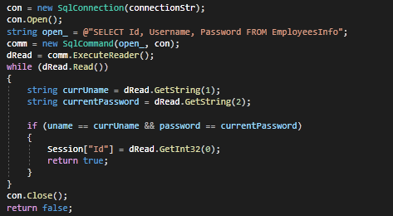

Read Game:

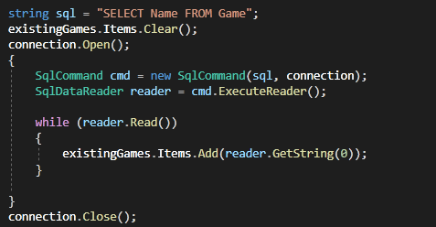

Read Many Tables:

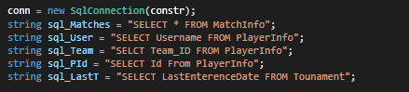

Read Matches:

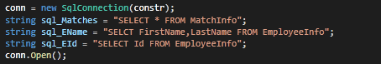

Read Multiple Tables:

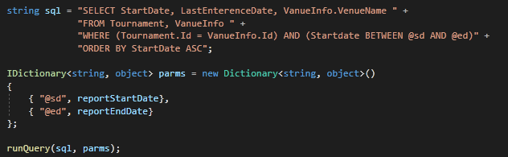

Read Player and Team:

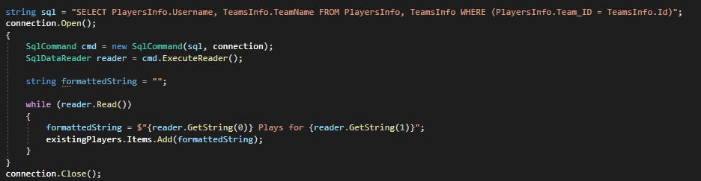

Read Venue:

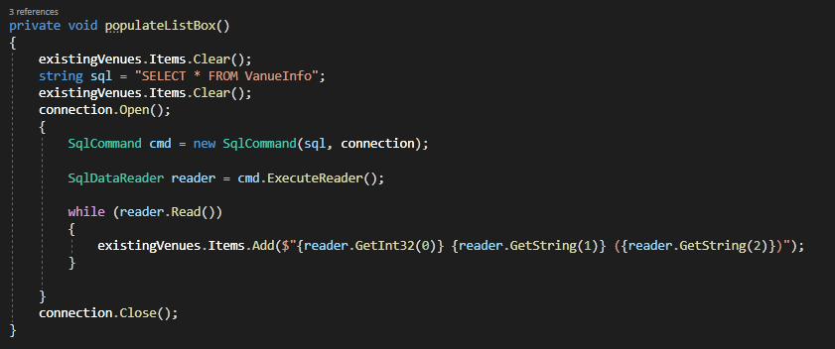

Update Team:



Venue Input Validation:

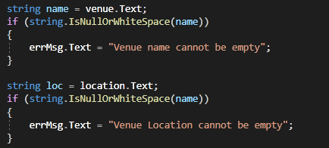

**Querying the Database**

Select and Update Player Info:

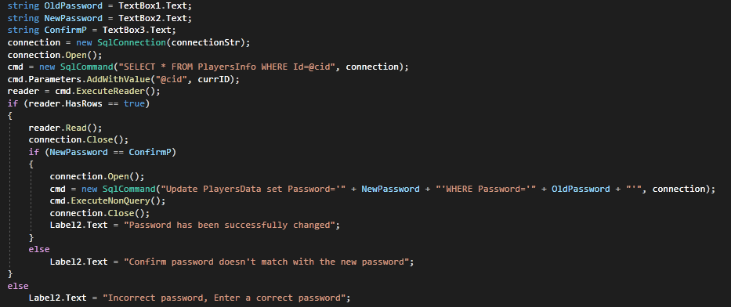

Select Platform:

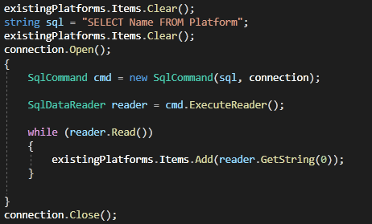

Select Existing Tournaments:



**Screen Print Reports**

Report 1:

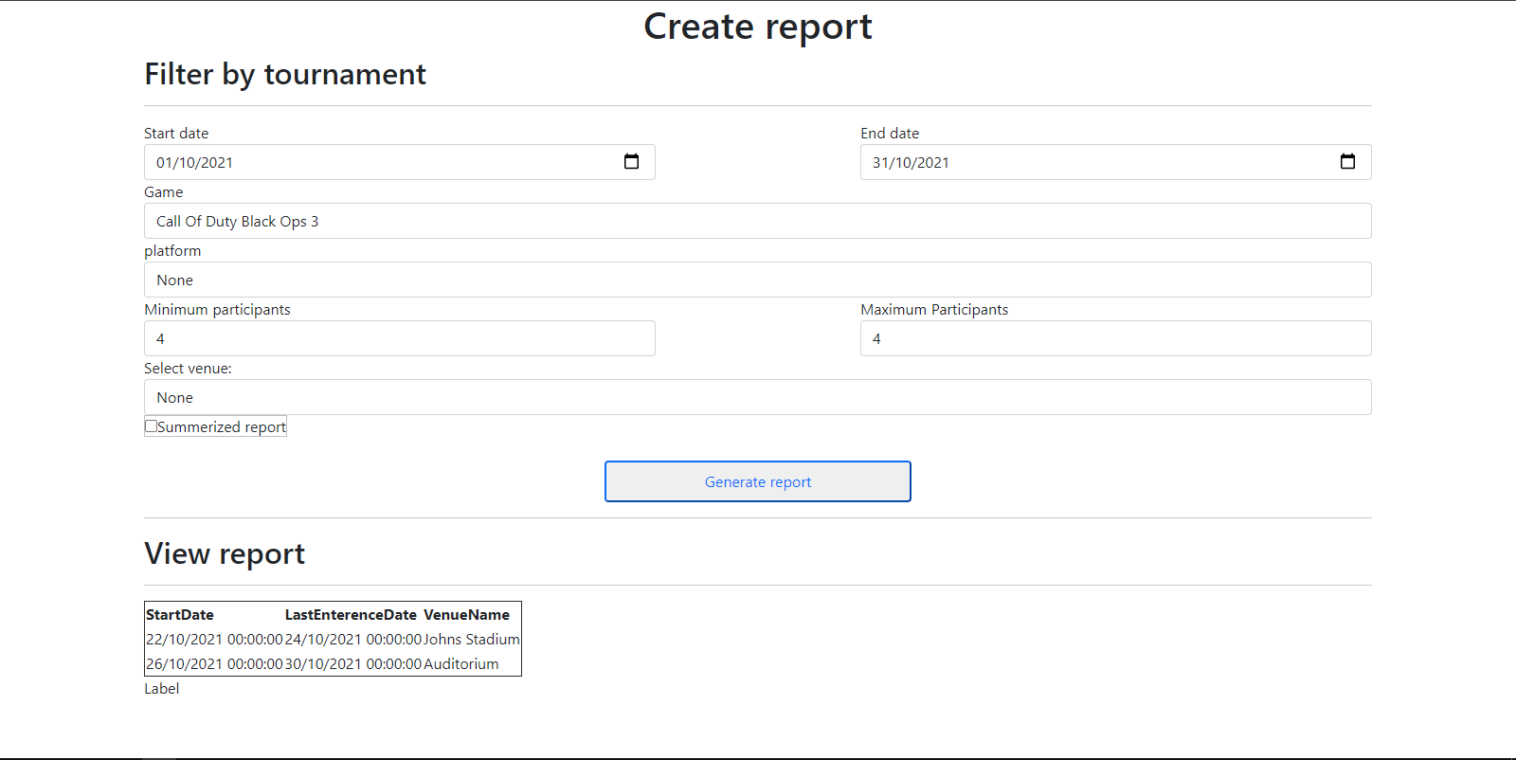

Report 2:

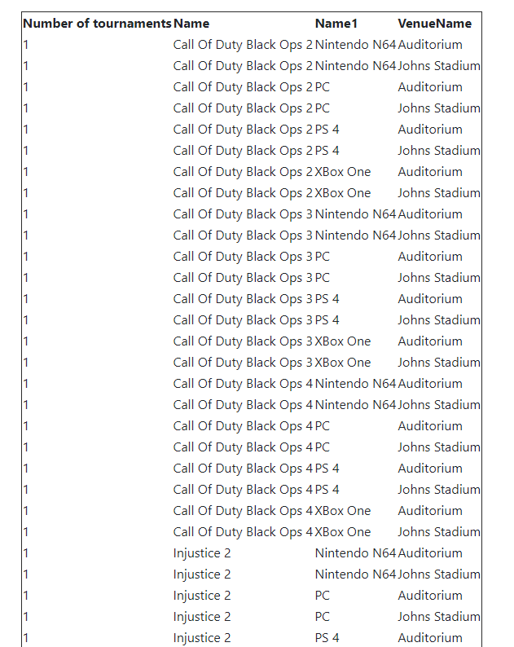

**User Manual**

|  |
| --- |
| Photo displaying partial image of two pie charts on a canvas-textured page |
| User Manual  CMPG 223 |
| |  |  |  | | --- | --- | --- | | Group 48 | [Date] | CMPG 223 | |

Table of Contents

Dependencies 2

Getting started 2

System Requirements 2

Hardware (Minimum) 2

Operating System 2

Dependencies

Please ensure that you have the required software before using the system

* Microsoft Visual Studio
* Dotnet SDK
* ASP.NET Framework
* Microsoft SQL Server

Getting started

To get started extract the contents of the zip, within the extracted folder navigate to the

CMPG-213_223-Project\Database\TournamentsDB

Directory and open the “TournamentDB.sln” file with Microsoft Visual studio and Launch “HomePage.aspx” by clicking the green play button near the top of the screen

System Requirements

Hardware (Minimum)

* Intel® Core™ i5-4570 CPU 3.20 GHz (Quad core)
* 150 Mb RAM
* Intel® HD 4600 GPU
* Recommended to use a x86-64 CPU software has not been tested on other architectures

Operating System

* Windows 10 21h1

Physical Data Model

Physical Process Models

Administrator

Data Model

Employee

Player

Maintain Game

Maintain Venue

Maintain Platform

Maintain Team

Maintain Score

**GITHUB DETAIL DAIRY**

